Eyeconic - Glasses Shop Management System

Use-Case Specification: M02 - Add User

Version 1.0

Revision History

|  |  |  |  |
| --- | --- | --- | --- |
| **Date** | **Version** | **Description** | **Author** |
| 05/11/2019 | 1.0 | Start creating use case | Hoàng Tiến Long |
|  |  |  |  |
|  |  |  |  |
|  |  |  |  |

Table of Contents

1. Add User 4

1.1 Brief Description 4

1.2 Actor 4

2. Flow of Events 4

2.1 Basic Flow 4

2.2 Exception 5

2.2.1 Add user 5

2.2.2 Fill in the information form 5

2.2.3 Confirming adding the user 5

3. Special Requirements 5

4. Preconditions 5

4.1 Login 5

5. Postconditions 5

6. Extension Points 5

Use-Case Specification: Add User

# Add User

## Brief Description

This use cacse defines the step of adding new user.

User are added by the admin.

## Actor

Administrator.

# Flow of Events

## Basic Flow

In user management, the system administration clicks the add button. The administrator fills in the information of the new User. The system displays the updated management parameter value and logs the change.

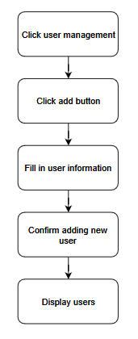

***Basic flow of adding user***

Step 1: Click management user.

Step 2: Click add button.

Step 3: Fill in user information.

Step 4: Confirm adding new user.

Step 5: Display added user.

## Exception

### Add user

The add button cannot be clicked or isn’t appeared on the screen

### Fill in the information form

Invalid information.

Must fill out all the information in the form.

### Confirming adding the user

The “Save” button is clicked but the new user is not added to the database.

This new user is existed in the database.

# Special Requirements

No Special Requirements

# Preconditions

## Login

Actor must already login as the administrator of the website.

Accuracy is required when administrator want to add user.

# Postconditions

# Extension Points

No extension points.